|  |  |  |
| --- | --- | --- |
| **LAB 321Assignment** | **Type:** | **ShortAssignment** |
| **Code:** | **J3.L.P0065** |
| **LOC:** | **150** |
| **Slot(s):** | **10** |

**Title:** Promotion Management

**Background**

Restaurant provide services that customer can order a party online. The restaurant also has promotion programs

**Program Specifications**

Program a web site display list of promotions and a page that allow a user to add new promotion

**Features:**

This website contains following main functions

* Function 1: Search Promotion
  + The list of promotion will be displayed
  + The promotion list must be paging
* Function 2: Add New Promotion
* Function 3: View Promotion Details

Database description

* Database must contain promotion detail information displayed on the screen

***Expectation of User interface:***

**PIC 1: List Promotions**

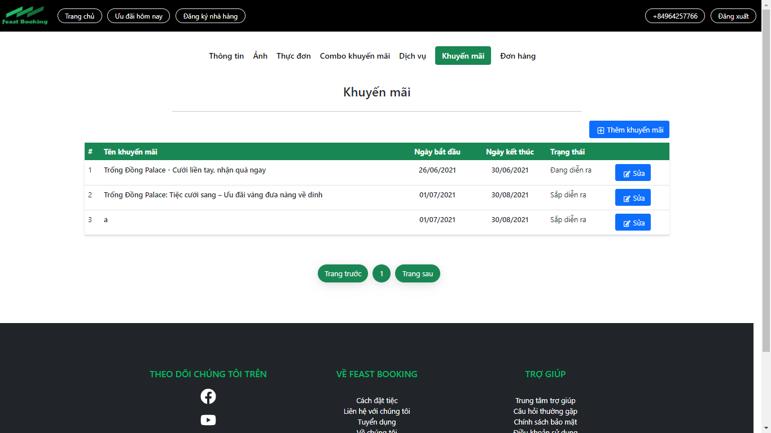

**Note: The following fields must be displayed**

1. Promotion Name
2. Promotion Value
3. Status
4. End date
5. Previous/Next button
6. Detail button : When user click on “Details” button, the system will display the **Promotion Detail** like page as P**IC02 but all field are read-only**
7. Add Promotion button: When the user click on “Add Promotion” button the system will display the Add New **Promotion** page as P**IC02**

**PIC 2: Add Promotion**

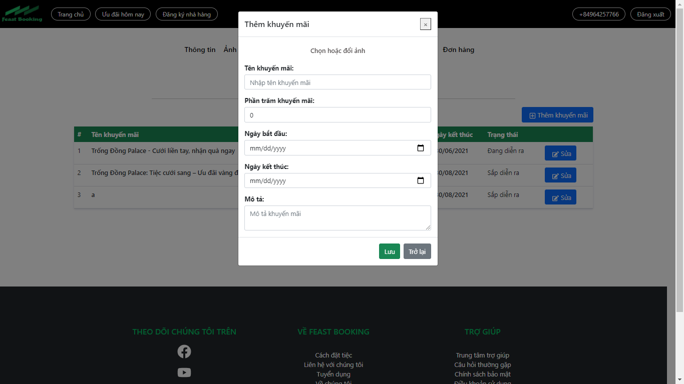

**Note: The following fields must be displayed**

1. All fields in the screen must be got from database
2. When user click on “Back”, the promotion list will be displayed
3. When user click on “Save”, the promotion list will be displayed

**Guidelines**

* Step 1 : Create web layout
* Step 2 : Create prototype
* Step 3 : Design database base on created prototype
* Step 4 : Code & Test